John Vos, James Shaw, Jack Whitchurch, Ross Jones

Abstract

Documentation of the process of building our VR escape room, such as; challenges, research, development, build levels, work done by which member

INTEGRATED GROUP PROJECT IN COMPUTING

Documentation

Table of Contents

Project Plan & Specification: 3

Game Concept: 3

Story board: 3

Teaching Concepts: 3

Contingency Plan: 3

Lesson plan: 4

Room 1: if statements (conditionals) 4

Room 2: for statements 4

Room 3: variables 4

Testing: 4

Group Meeting: 4

Software being used: 4

Team Roles: 5

Ross 5

Jack & James: 5

John: 5

Ross & Jack: 5

Jack, James & John: 5

Room Design: 6

Room 1: The Lab 6

List of steps to complete the room: 6

Room Design: 6

Room 2: Kitchen 7

List of steps to complete the room: 7

Room Design: 7

Room 3: Bedroom 8

List of steps to complete the room: 8

Room Design: 8

Puzzle Research / Concepts: 9

Puzzles: 9

Black light; 9

Hidden items; 9

Maze: 9

Puzzle solutions: 9

Clue: 9

Use Cases: 10

Use Case 1: 10

Use Case 2: 11

Use Case 3: 12

Use Case Modelling: 13

Time Frame: 14

Proposed project plan timeline: 14

Challenges encountered: 15

Ross 15

Jack: 15

Challenges encountered: 15

James: 15

John: 15

Change Log: 16

Progress report: 18

Original Pitch: 18

Game first design with textures: 19

Game stage 1: 20

Game interior: 22

Interaction with objects: 25

Final Game Screenshots 26

Blender: 34

Glossary: 35

References 36

# Project Plan & Specification:

## Game Concept:

The game will be a VR escape room aimed at KS3 (11 to 14-year olds) students studying computer science using unity (version 2018.3.6) for windows on the Vive VR set. Furthermore, as the game is an alpha version we will be keeping it to 4 rooms teaching the key concepts of Java. However, the end goal is to have a full game teaching multiple languages, such as Python, JavaScript, C, etc...

The player will have 1 hour to complete 3 puzzles to activate a shield to protect the ship. We chose 1 hour as the game is in VR and any more than an hour in the headset can be too much and disorientate the player, especially as the target audience is young. Research has also found that 2 hours is the max amount of time one should spend in VR at one time.

## Storyboard:

The background story of the game and that the player will be presented with once they load into the game is that you are working on a spaceship and receive a communication that attackers are on their way to attack you and that the attacker’s goal is to corrupt and destroy your groundbreaking scientific research that is on board the station by uploading errors into your code that you have been developing. The player will load in next to the science lab which is based on if statements that the player will need to learn and the objective of this room is for the player to find a way to protect themselves and the station so that the research doesn’t get into the wrong hands, once they have completed the puzzle and in the process learnt if statements a protective force shield will be raised around the base. The player will then venture further into the space station moving onto the kitchen which goal is to teach the player for loops, the player must then complete several steps which will the protect the ship further by placing an invisibility cloak around the space station, so the station is hidden from invading fleets. The final room which is the bedroom will teach the user variables. For this, they will have to figure out how to open the safe to find the final key that will unlock the escape pod. There will also be an AI voice that will alert the player of their situation and prompt them as to what they need to do. Furthermore, the AI voice will be a friendly scientist that will add backstory and guidance.

## Teaching Concepts:

We will be using small and simple code blocks to teach key concepts of computer science coding. For the “assignment” version of the game, we are focusing on building only 4 rooms due to the time constraint and skill level in regard to unity and VR. However, the full game would have a room to teach the concept and a save/load function.

## Contingency Plan:

We are starting by making room 1 for VR and then getting the VR headset and controls to work, as none of us has any previous experience with Unity or VR. Once we get the first room built and controls working we are going to start with the first puzzle room to give an idea of the challenges and difficulty we are going to face during the development of this project. This will determine if we continue with the VR or switch to a mouse and keyboard game. if this does indeed prove too much of a challenge for the time frame we have set and to be able to deliver a working VR escape room our fall-back plan is that we will develop a 2D game instead.

## Lesson plan:

### Room 1: if statements (conditionals)

A key concept of coding is the ability to run through something a set amount of times determined on if a certain condition is met; i.e. the condition is *true* it will complete the desired thing. Therefore, we will use these to introduce the concept of how loops are used to run through a certain code (command) a set amount of times or till a task is complete. We will be teaching in the VR game in room 1 using a text prompt on a monitor that gives the player an if statement that will guide them through clues to solve the first puzzle.

### Room 2: for statements

A key feature of coding is the ability to loop through the code to facilitate the execution of a certain set of instructions and functions a certain amount of times. The for loop is a concise loop structure, that is given an initialisation condition and can then increment or decrement in using only one line of code providing a much shorter and easier loop structure than other loops and is also easier to debug.

### Room 3: variables

A key concept is variables as they are an absolute fundamental that no code would work without, therefore we have chosen to implement this as a teaching deliverable. Furthermore, as we are teaching Java in this version of the game, we are teaching the declaration of variables as you would in a Java program. We will use this style of teaching variables to the users as it is clear and concise and an excellent visual way of representing something rather basic in terms of coding but a fundamental. Furthermore, as the target audience is 11 to 14-year olds with no previous knowledge of coding it is essential the information is absorbed.

## Testing:

We will test the game ourselves as we develop each room, we will also bring in friends and family members to play and test the game as well as give feedback on a regular basis.

## Group Meeting:

We chose to meet up every Wednesday as the due date for most of our deliverables as this is when we are always able to meet up every week and the day before our tutorial where we will be getting feedback. Furthermore, we will also communicate on other days to come in and work together via discord

## Software being used:

* Unity version 2018.3.6 to develop the game.
* Vive VR as the platform on which it will be played.
* Discord server to communicate on dates we come in and progress.
* GitHub to track progress.

# Team Roles:

Ross:

3D assets:

Responsible for the creation and development of functional and interactable 3D assets using Blender. Though he has no experience with blender, he thought this would be an interesting challenge and a concept he is interested in and so that the game has some assets created by us for originality rather than just using assets off the store. The full game would feature assets purely created by us, however, due to the time constraints this is not realistic, and we only need assets for the puzzles that the player is interacting with.

## Jack & James:

Programmer:

Responsible for development and implementation of the programming that will make the game functional, such as; doors opening, puzzle functionality, environment intractability. Furthermore, responsible for creating the scene (i.e. room implementation) in unity from a combination of 3D assets made by Ross and assets from the Assets Store so that the visuals of the game are realistic and visually plausible.

## John:

Admin / Project Manager:

Responsible for writing the documentation and keeping it up to date for it to properly document and determine that all requirements of the coursework are met in full and keep track of all deliverables and progress as the projects grows and continues. Furthermore, if the project was to be taken over by other persons other than the ones currently listed, they can easily inform themselves of what has been done, how and why to be able to further continue the game. Furthermore, responsible for making sure all deliverables and goals are met on time and in full.

## Ross & Jack:

Sound Effects:

Responsible for the development of voice prompts for the user, such as backstory, hints, directions. This is a key part of the game as studies have found that when users are exposed to learning via an auditory stimulus they performed 64% better on assessments than people who learnt only via text (Kalyuga, Chandler and Sweller 1999).

## Jack, James & John:

Room Design & Implementation:

Responsible for the design and visual look of the game, as well as, implementation. This involves designing the room layout on paper and then putting all the assets in the respective places and changing the size of the assets according to be visually realistic and plausible in a 3D VR environment.

# Room Design:

## Room 1: The Lab

This room focuses on teaching the player the key aspects of if statements, which the player must apply to be able to solve the puzzle and unlock the final door to be able to escape the base via the escape pod. When the player first loads in they will be prompted to enter the lab and follow on-screen directions to solve the first puzzle via voice commands.

### List of steps to complete the room:

1. The player will enter the room and see the items around them.
2. The player will be prompted to read instructions on the computer screen.
3. After reading the text on the computer screen, the player will begin searching for the first clue.
4. The player will find the first clue underneath the desk.
5. Once the player has read the letter they will have to shine a light using the flashlight onto the paper to reveal a hidden message.
6. The hidden message will tell them to look behind the bookcase for the third clue.
7. The third clue will prompt the player to look for the power cell hidden in the bushes.
   1. it must then be placed on the power shell to prompt the next step.

### Room Design:

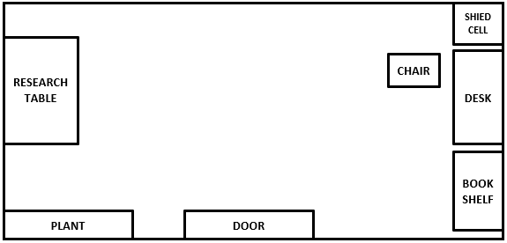

## Room 2: Kitchen

This room focuses on teaching the player the key aspects of for statements, which the player must apply to be able to solve the puzzle and unlock the final door to be able to escape the base via the escape pod. Once the player has entered the kitchen they will see text on what appears to be a menu and postcards on the wall, clues are hidden within these.

### List of steps to complete the room:

1. The player will enter the room and see the items around them.
2. A voice prompt will tell the player what their next task is.
3. They will read from the menu board which hints to them the location of the next clue.
   1. the clue is hidden in a for statement.
4. The next clue is hidden under postcard number 5.
   1. hinting to press the button under the desk.
5. Once the player presses the button text will appear on the board on the window giving the player the coordinates that need to be inputted into the ship locator.
6. Once the player has updated their location using the ship locator they will be prompted to move onto the next room.

### Room Design:

**PLANT**

**TEXT PANNEL**

**CONTROL PANE**

**CHAIR**

**SHIP LOCATOR**

**CHAIR**

**CHAIR**

**CHAIR**

**POST**

**CARD**

**WALL**

**DINNING**

**TABLE**

**TABLE**

**DOOR**

## Room 3: Bedroom

This room will focus on teaching the player aspects of variables, which the user must then apply to solve the final puzzle. For the variables in this instance, we will only be teaching strings. This is the final lesson the player will be taught on this level and give them the final piece to use to unlock the escape pod.

### List of steps to complete the room:

1. Once the player enters the room they will see the bedroom containing a pc screen with commands, a safe and a maze.
2. The player will be prompted by the voice commands and computer monitor to unlock the safe to finally escape.
   1. the pc monitor will prompt the player to look underneath the pillow.
3. Once the player looks underneath the pillow they will find a note telling what colours will do what.
   1. they must find the hint hidden on the chalkboard telling them to interact with the crystals on the shelf.
4. By placing the correct coloured crystals in the correct order, it will move the ball in the maze along the route to solve this puzzle.
5. Once the maze is solved it will unlock the safe and they can escape the space station.

### Room Design:

**SHELF**

**PLANT**

**BED**

**BED**

**DOOR**

**SAFE**

**CONTROLLS**

**DESK**

**MAZE**

# Puzzle Research / Concepts:

## Puzzles:

### Blacklight;

Difficulty 1) have the player turn on the black light to reveal a hidden code or pattern.

Difficulty 2) have the player search for a cable to attach to the black light then to the plug, to reveal the hidden code or pattern.

Code Difficulty 1) have the code display a 4 digit number for the lock, e.g. 1234.

Code Difficulty 2) have a code disguised as a pattern of lines representing the digits.

Code Difficulty 3) have a full wall covered in symbols and numbers, e.g. certain colour code.

Pattern Difficulty 1) pattern is displayed when the light comes on, e.g. a rectangle.

Pattern Difficulty 2) have the pattern hidden in scrambled lines, solution is a particular colour.

### Hidden items;

Difficulty 1) have key cards or playing cards with numbers on them hidden for the player to find, the colour will indicate the order, the colour will be shown on the keypad, e.g. green box around the first digit.

Difficulty 2)

Hiding places) in boxes / under carpet / coat / inside a book / draw / behind a plug.

### Maze:

Difficulty 1) have the player drag a pin along a maze into the hole.

Difficulty 2) player has a time limit to solve the maze.

Difficulty 3) the maze will move as the player moves the pin along the hole.

### Puzzle solutions:

Hidden code = safe / phone / computer / padlock.

Hidden pattern = phone / tablet.

### Clue:

Glow in the dark clue.

Morse code.

Pressure plate.

# Use Cases:

## Use Case 1:

**Use Case:**

 The player loads into the game and learns the controls.

**Primary Actor:**

 Player.

**Secondary actors:**

Vive headset and controls.

**Goal:**

For the player to feel comfortable manoeuvring around the game and interacting with objects and the puzzle.

**Preconditions:**

The game has launched successfully without any errors and the “Vive” headset and controllers are working and connected.

**Success End Condition:**

The player is comfortable with the environment and controls and begins attempting to solve the puzzles.

**Failed End Condition:**

1. The game does not launch.
2. The headset or controllers do not connect.
3. The player gets motion sickness.

**Trigger:**

1. Failure to log into steam or an error is returned from the game.
2. The controller or headset is not detected.
3. Due to the 3D environment and playing too long the player begins suffering from disorientation and motion sickness.

**MAIN SUCCESS SCENARIO**

1. The player puts on the VR headset and has a controller in each hand.
2. The player is loaded into the game.
   1. the player looks at their hands and sees icons telling them what each button does.
3. The player beings moving around the map and interacting with objects using the HTC Vive controllers.
4. The player solves each puzzle and escapes the space station.

## Use Case 2:

**Use Case:**

 Solving a puzzle.

**Primary Actor:**

Player

**Secondary actors:**

Puzzle

Vive headset and controls

**Goal:**

For the player to solve the puzzles and escape the research station.

**Preconditions:**

The game has launched successfully without any errors and the “Vive” headset and controllers are working and connected.

**Success End Condition:**

The player solves the puzzles without any errors being encountered from the VR kit and within the time limit.

**Failed End Condition:**

1. Failure to log into steam or an error is returned from the game.
2. The controller or headset is not detected.
3. Due to the 3D environment and playing too long the player begins suffering from disorientation and motion sickness.
4. The player is unable to solve the puzzles in the time limit.

**Trigger:**

1. Failure to log into steam or an error is returned from the game.
2. The controller or headset is not detected.
3. Due to the 3D environment and playing too long the player begins suffering from disorientation and motion sickness.
4. The player took longer than the allocated time limit to solve the puzzle.

**MAIN SUCCESS SCENARIO**

1. The player puts on the VR headset and has a controller in each hand.
2. The player is loaded into the game.
   1. the player looks at their hands and sees icons telling them what each button does.
3. The player beings moving around the map and interacting with objects using the HTC Vive controllers.
4. The player begins interacting with the environment and collecting clues to solve the puzzles.
5. The player solves all the puzzles in order and escapes the station.

**EXTENSIONS**

4. The player begins interacting with the environment and collecting clues to solve the puzzles.

a. the player solves the first puzzle that involves if loops.

b. the player solves the second puzzles that involved for loops.

c. the player solves the third puzzle that involves strings.

## Use Case 3:

**Use Case:**

**Primary Actor:**

**Secondary actors:**

**Goal:**

**Preconditions:**

**Success End Condition:**

**Failed End Condition:**

**Trigger:**

**MAIN SUCCESS SCENARIO**

1. A

**EXTENSIONS**

<put here the extensions, one at a time, each referring to the relevant step of the main scenario>

<step altered><condition>:<action>

# Use Case Modelling:

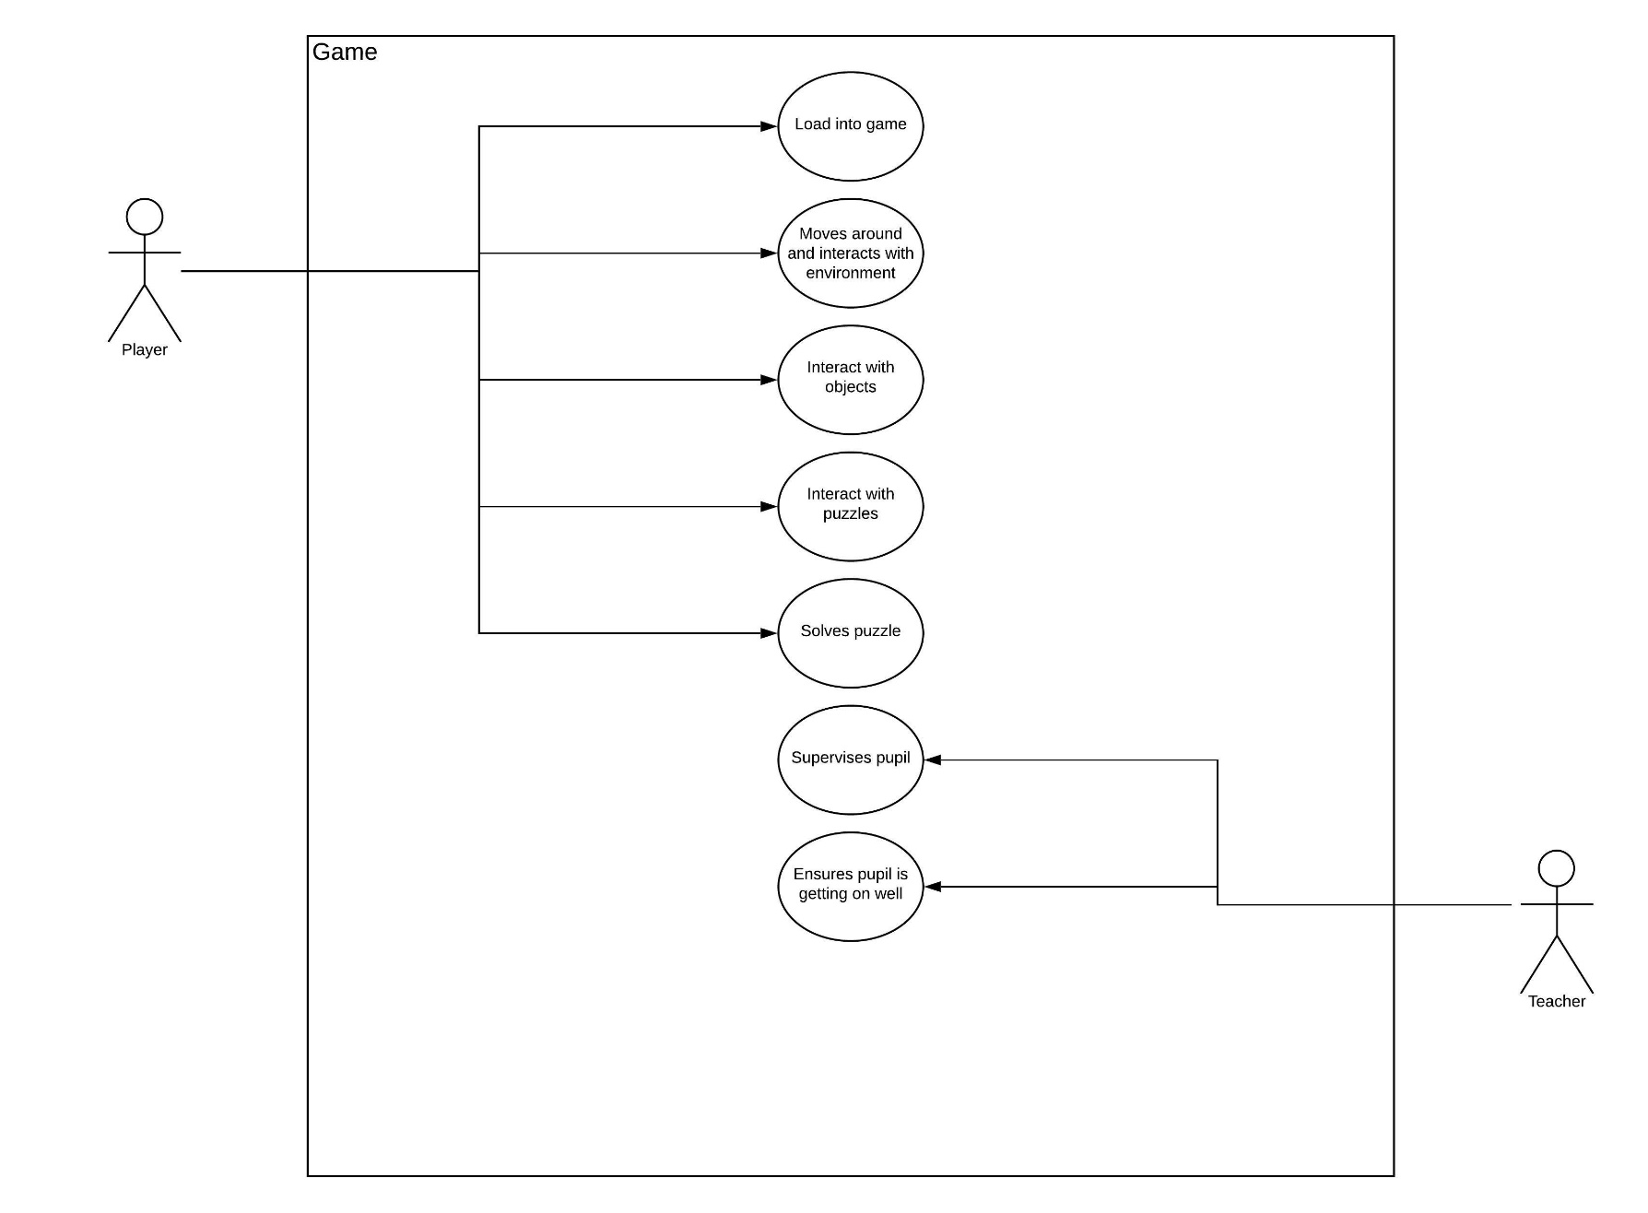

# Time Frame:

## Proposed project plan timeline:

|  |  |  |
| --- | --- | --- |
| **Goal** | **Deadline Date** | **Person Responsible for development** |
| Puzzle room 1 research | 13th March | John & Ross |
| Room 1 layout & textures | 13th March | Jack & James |
| Room 1 puzzle implemented | 20th March | John & James |
| Testing Room 1 | 21st March | Everyone |
| Puzzle room 2 research | 21st March | John & Ross |
| Room 2 layout & textures | 27th March | John & James |
| Room 2 puzzle implemented | 27th March | Jack & James |
| Testing Room 2 | 27th March | Jack & James |
| Puzzle room 3 research | 3rd April | John & Ross |
| Room 3 layout & textures | 3rd April | John & James |
| Room 3 puzzle implemented | 3rd April | Jack & James |
| Testing Room 3 | 3rd April | Jack & James |
| Puzzle room 4 research | 10th April | John & Ross |
| Room 4 layout & textures | 17th April | John & James |
| Room 4 puzzle implemented | 24th April | Jack & James |
| Testing Room 4 | 24th April | Jack & James |
| Tutorial layout & textures | 1st May | John & James & Ross |
| Final game testing | 8th May | Everyone |
| Submission Date | 13th May | James |

# Challenges encountered:

Ross:

I went in with no prior experience with Blender and therefore had to learn the basics to be able to produce the desired assets. To achieve this, I began watching online videos/tutorials and subscribed to various YouTube channels that covered Blender tutorials. This has then led to the development of various assets being made and me gaining a skill base in Blender and gaining the ability to develop assets for our project.

## Jack:

### Challenges encountered:

## James:

With little to no prior experience in unity, one of the major challenges I faced was making sure that objects were the correct size, i.e. not too big or small so when the player is in the 3D environment all assets look realistic as the 3D environment appears much bigger than on the 2D editing environment. Moreover, making sure that none of the walls were overlapping as this caused a strange flashing effect. Another challenge I faced was the animation of the doors and getting them to work at the correct time and the player being in the correct distance, this was especially prevalent when we moved assets around the values set were no longer correct. To resolve this issue, I had to do lots of testing with different lengths from the door to ensure that the door opened when we wanted. One issue I encountered which I did not foresee was having to decide what to keep and what to get rid of from our original idea to ensure we finished on time.

## John:

Having absolutely no experience with Blender or Unity and not being the best in the group at coding and after a small discussion with my teammates, we allocated each other roles that best suit our skill set and as a result, I took it upon myself to stay on top of the documentation and being the project manager. Though my fellow teammates were very organised and did deliver their allocated tasks on time, a major challenge I found myself facing was getting all the information down on paper and picking up any slack. I very quickly found myself creating an asset on Blender and trying to learn the basics to help my team and spending countless hours in the VR lab helping implement the room design and guiding the team towards the pictured and discussed plan.

# Change Log:

2/03/19

- Uploaded the Pitch presentation to the Github

04/03/19

- Created unity project

- Imported Standard Assets Package

- Played around with making rooms with objects within unity and testing different lightings

14/03/19

- Updating documentation to add use cases

- More testing different room design ideas

- Changed the skybox to a space theme

19/03/19

- Removed unused and unnecessary assets to reduce the total project size

27/03/19

- Added VR movement and interactability

- Updated the format of the documentation

- Made sure that all information and screenshots on the documentation are up to date

28/03/19

- Captured a screen record of the project so far

- Removed the rigid body component on the player object as this was causing issues with the player movement

15/04/19

- Added glass walls and doors in the first room to section off where the first two puzzles will be placed

- Added more information in the documentation about room designs and puzzle plans

16/04/19

- Added glass walls and doors in the second room to section off where the last two puzzles will be placed

- Added door functionality through animations

19/04/19

- Added objects in the third room to create a science lab theme room

- Changed the skybox so that the earth is seen from outside the window

29/04/19

- Imported the safe from blender to Unity and played around with animations to get the functionality

30/04/19

- worked some more on implementing functionality on the safe door

02/05/19

- Testing rooms to ensure that everything is the right size and interactable objects work as they are supposed to.

04/05/19

- Added the maze and maze controllers

- Added background sound to the game

16/05/19

- Developed scripts for the game's AI

19/05/19

- Added puzzles in the lab room and the kitchen room

20/05/19

- Added the voice audio to the game

21/05/19

- Testing and bug fixing

23/05/19

- Final testing and debugging

# Progress report:

## Original Pitch:

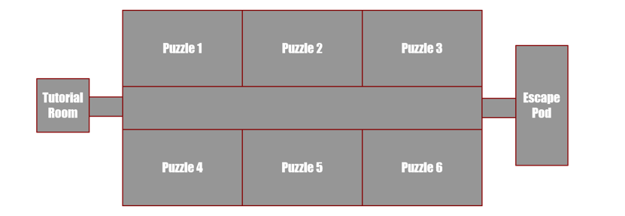

## Game first design with textures:

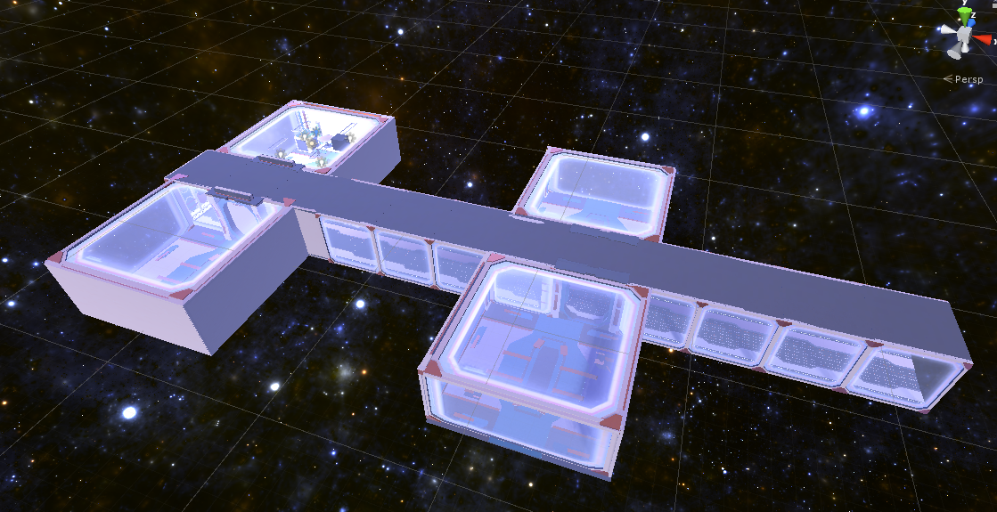

## Game stage 1:

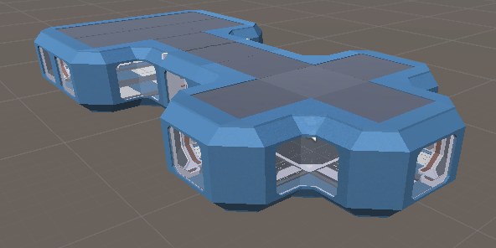

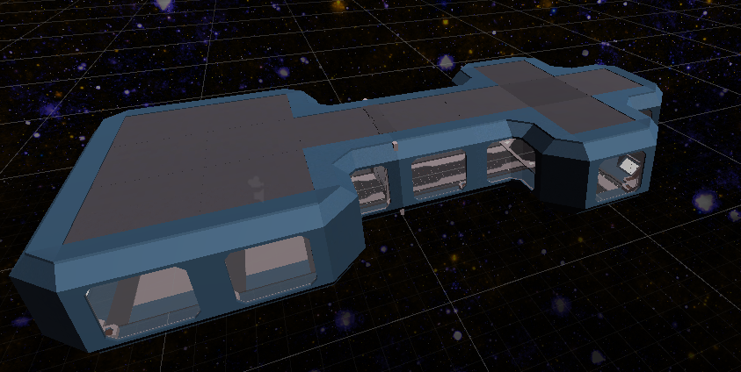

## Game interior:

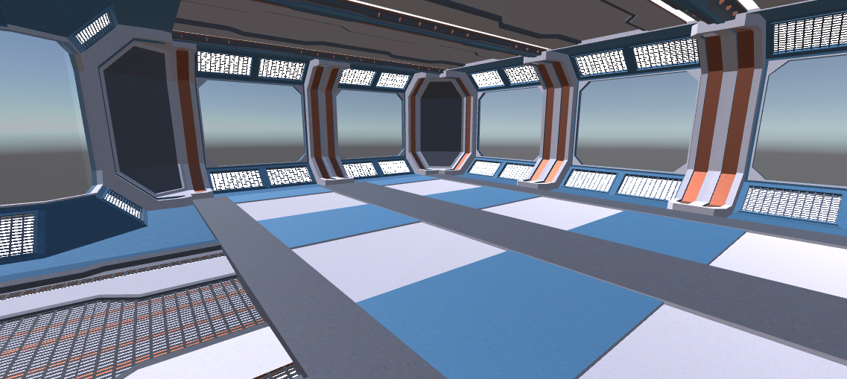

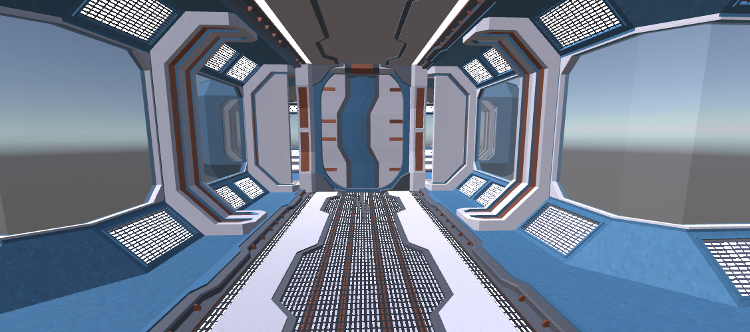

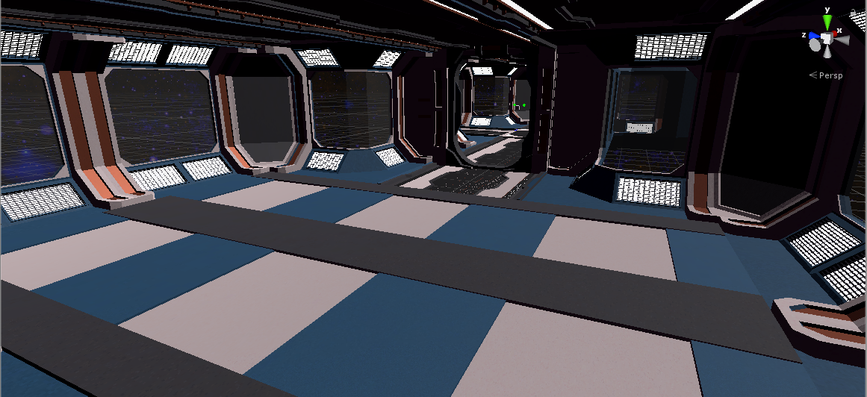

## Interaction with objects:

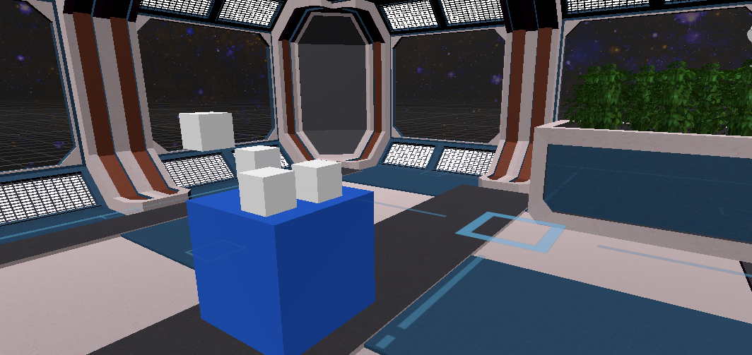

## Final Game Screenshots

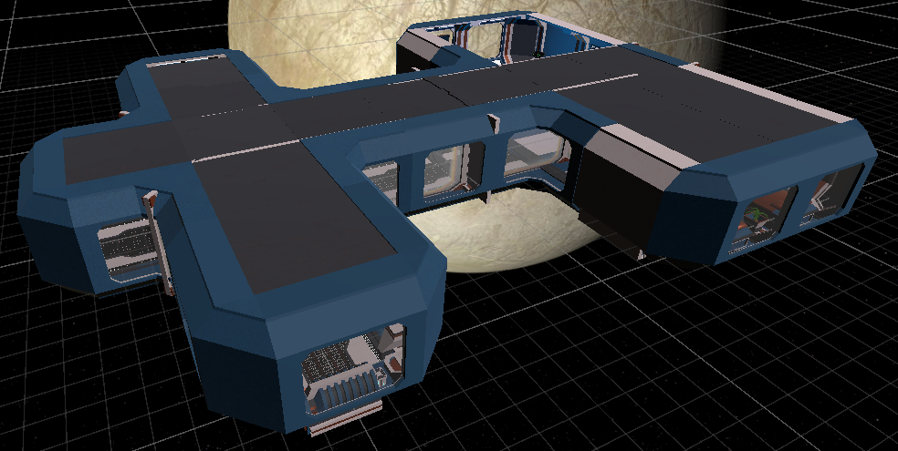

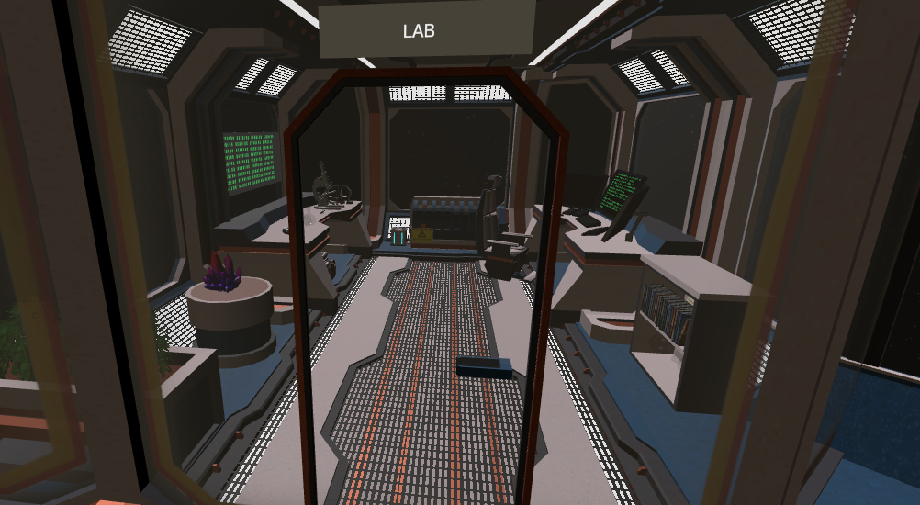

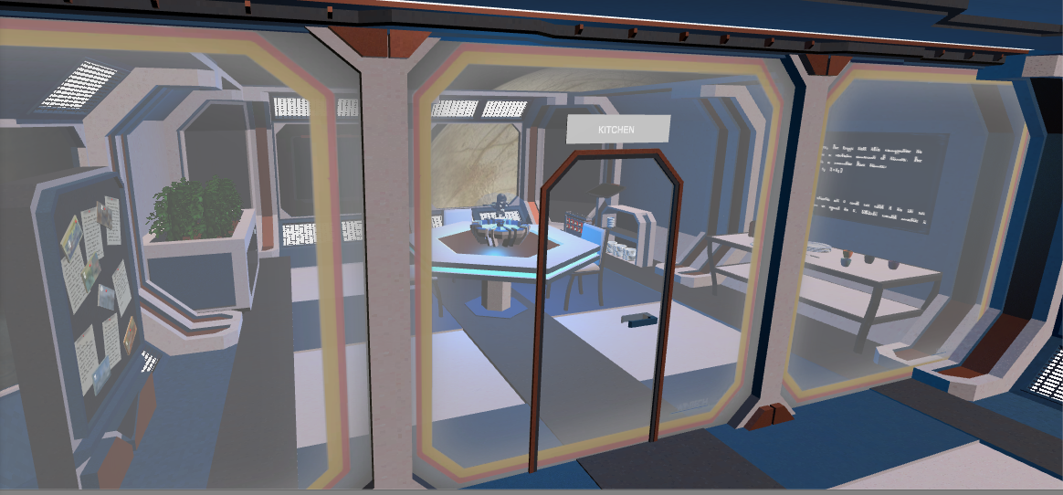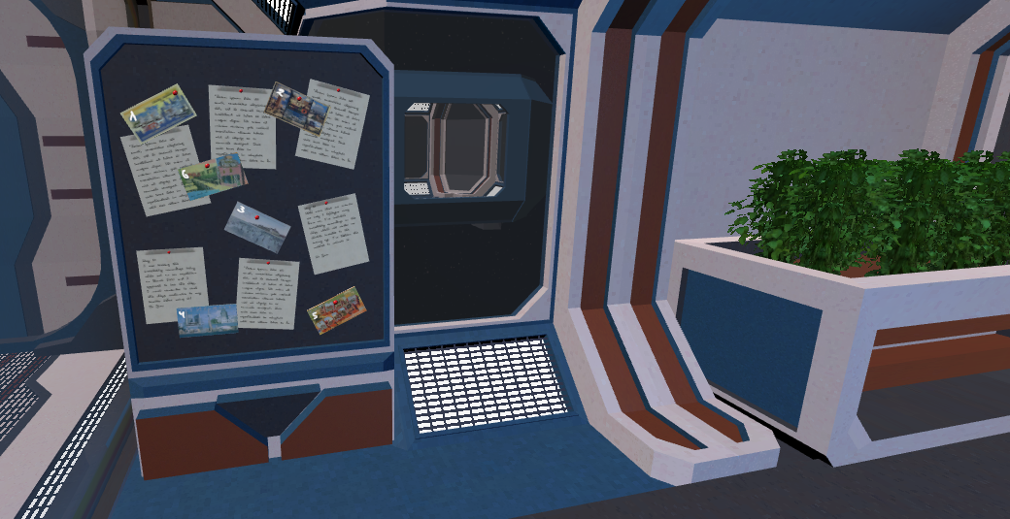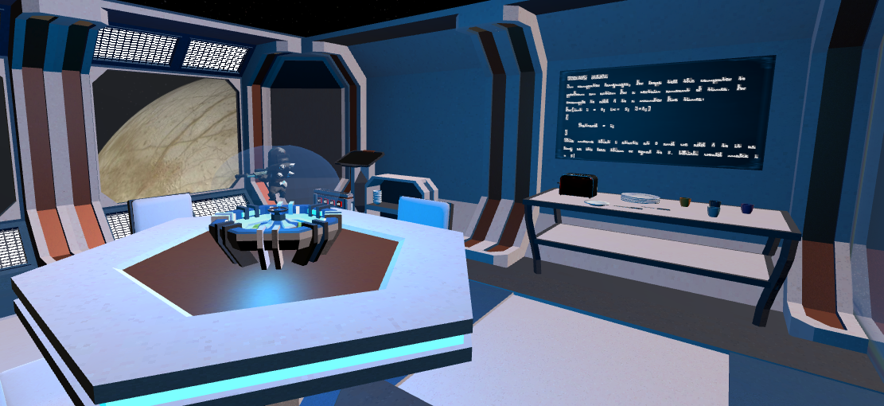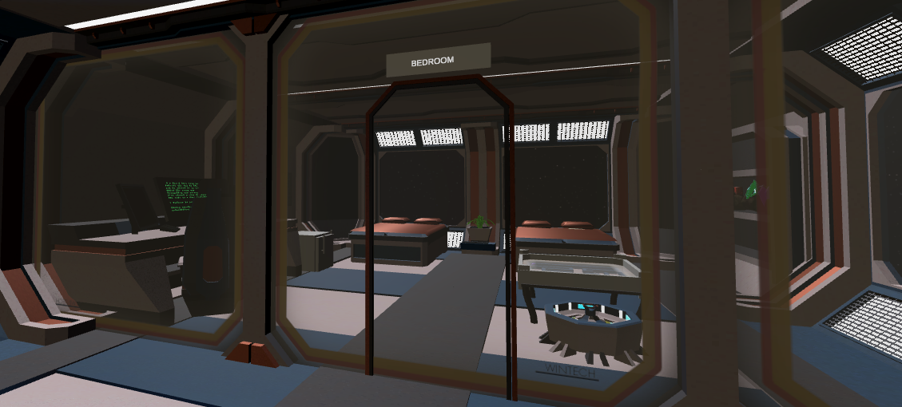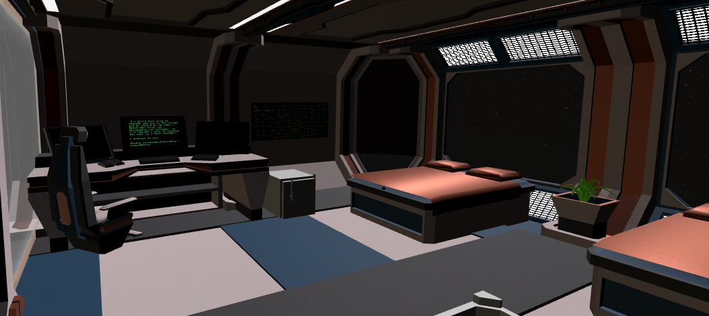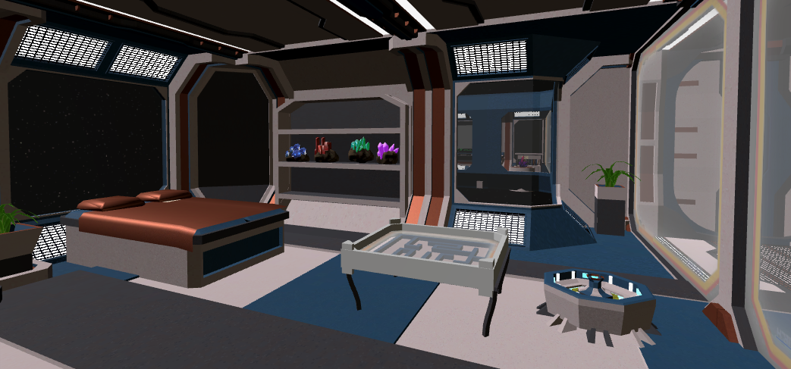

## Blender:

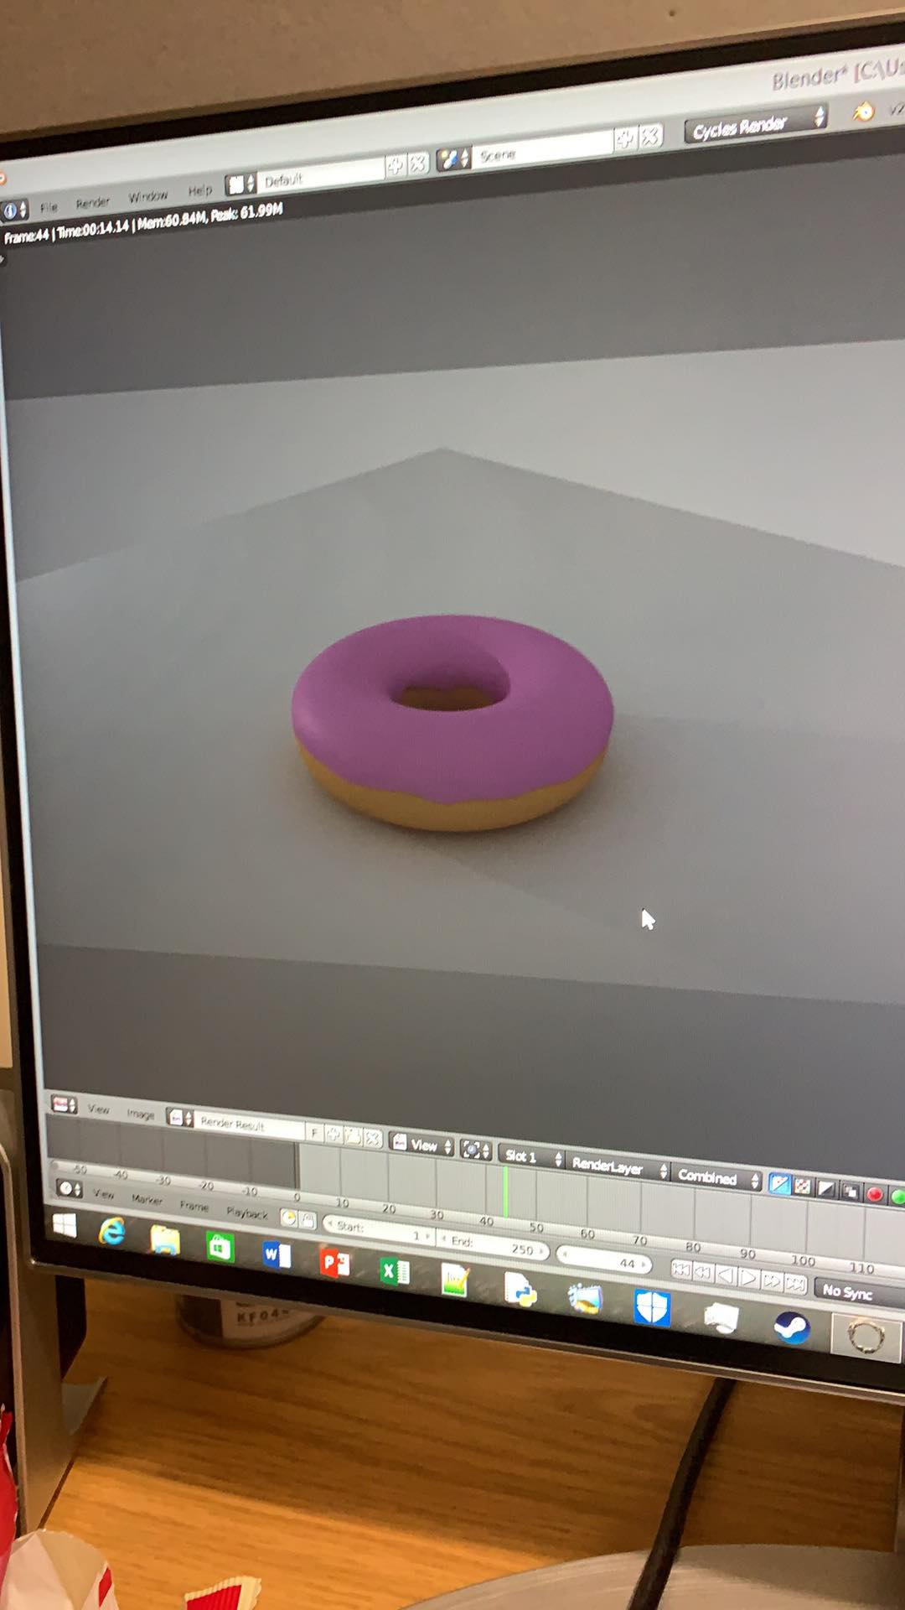

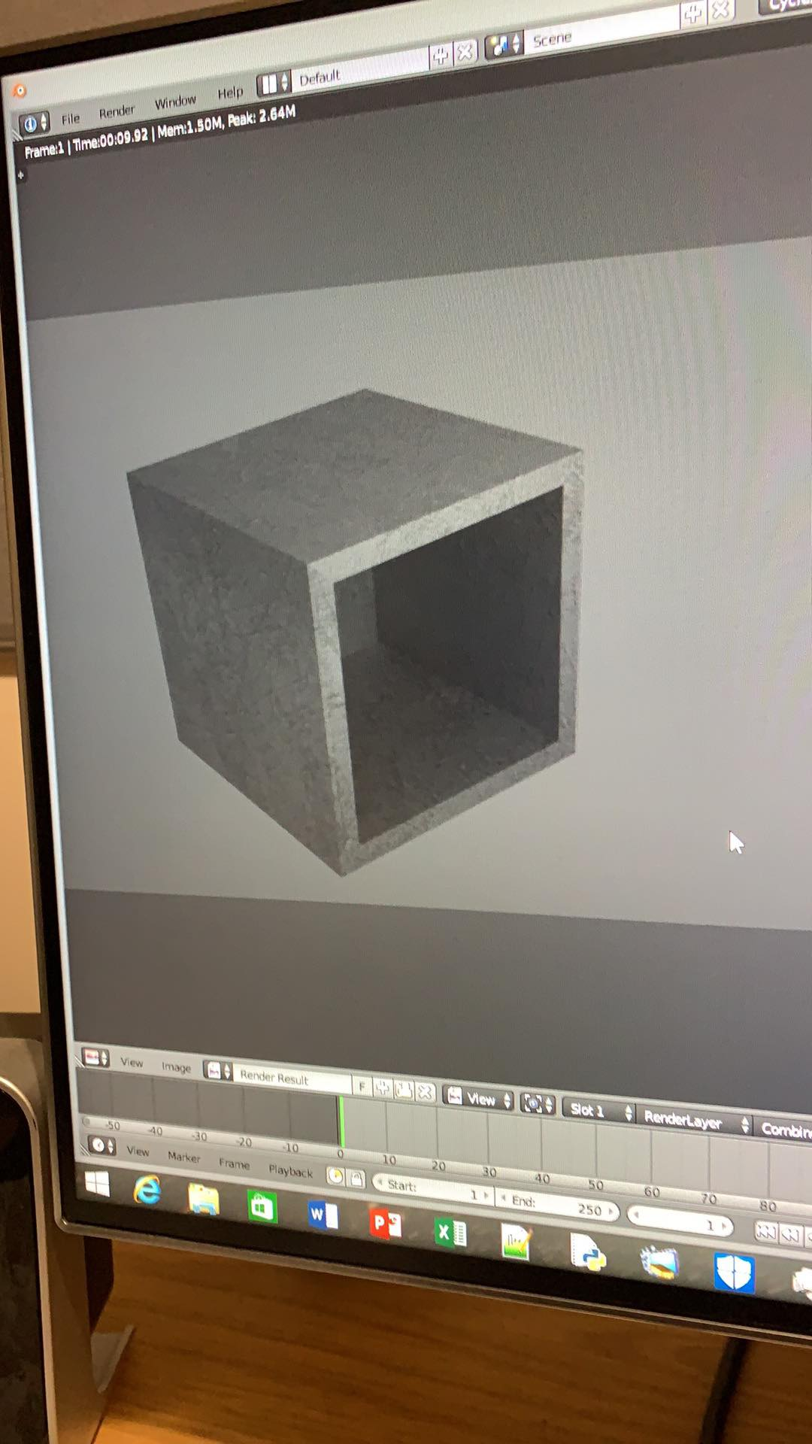

# Glossary:

|  |  |
| --- | --- |
| **Word:** | **Definition in regard to the project:** |
| functionality | the quality and suitability to achieve the desired result. |
| implementation | the process of putting a function into the project. |
| intractability | the ability to link perceptual information, e.g. the ability to move objects to solve a problem. |
| playability | that the player can easily interact with the game and achieve the goal with ease. |
| deliverable | something to be provided in the final product in the development process. |
| prompt | an event that will cause or bring about certain actions from the player. |

# References

Amaze, J., 2010. *Maze Generator.* [Online]   
Available at: http://www.mazegenerator.net/

Brown, E., 2016. *Leo Learning.* [Online]   
Available at: https://leolearning.com/2016/10/the-use-of-audio-in-elearning/

Escape, Q. C., 2016. *Queen City Escape Room.* [Online]   
Available at: http://www.queencityescape.com/top-20-puzzle-ideas/

Trica, A., n.d. *Filtered.* [Online]   
Available at: https://filtered.com/blog/post/project-management/the-importance-of-documentation-in-software-development

William, 2016. *Escape Room Tips.* [Online]   
Available at: https://escaperoomtips.com/design/escape-room-puzzle-ideas